Setup react | node.js project
Backend setup:
npm init -y
npm install --save-dev typescript
npx tsc –init
npm i express
npm i --save-dev @types/express
npm i --save-dev @types/cors
npm i --save-dev @types/dotenv
npm i --save-dev @types/cookie-parser
npm install -D tsx
npm i cors
npm I dotenv
npm I cookie-parser
npm run dev
Setup package.json
"scripts": {
"dev": "node server.js"
},
Setup tsconfig.json
Setup Prisma
npm install prisma@6.10.1 --save-dev
npm install @prisma/client@6.10.1
Prisma Schema
generator client {
provider = "prisma-client"
output = "../generated/prisma"
}
datasource db {
provider = "postgresql"
}
Migration
npx prisma migrate dev --name init
npx prisma generate
reset all migration
npx prisma migrate reset
delete migration folder
rmdir /s prisma\migrations
Authentication packages
npm install jsonwebtoken bcryptjs
npm i -D @types/jsonwebtoken
setup package.json
backend: "dev": "set PORT=5005 && tsx watch src/server.ts",
frontend: "dev": "next dev -H 0.0.0.0 -p 3006",
Front end setup
- npx create-next-app@latest frontend –typescript
npm install axios
npm install --save-dev @tanstack/react-query-devtools
npm I sweetalert2
npm i -D tailwindcss postcss autoprefixer
npm I clsx
- npm I zod
npm install react-hook-form @hookform/resolvers zod
Front end icons library
npm install lucide-react
Chart Library
npm install recharts
Industry Standard Backend Architecture
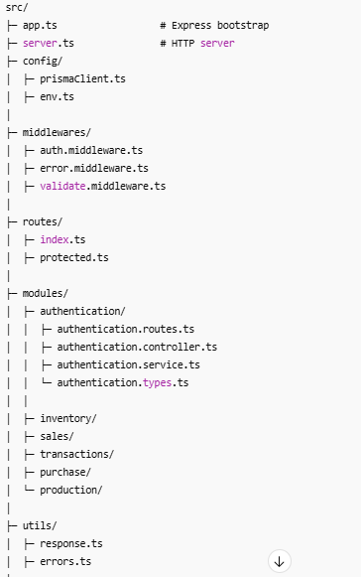
Front end structure
.next/
App/
- Components – components
  - Modal
  - Button designs
  - Table – table component
- Context
- Guards
- Hooks
- Pages
  - Admin –admin pages
    - Page.tsx
    - Layout.tsx
    - Config – sidebar configuration
  - others
- Providers
- Schemas – data schema
  - Auth.schema.ts – main schema with zod
- Services
  - Api route connections in backend
- Types
- Unauthorized
- Utils
- Layout.tsx – main layout
- Page.tsx - login page
node_modules/
public/

